**Lab 02**

* Import the “student” database

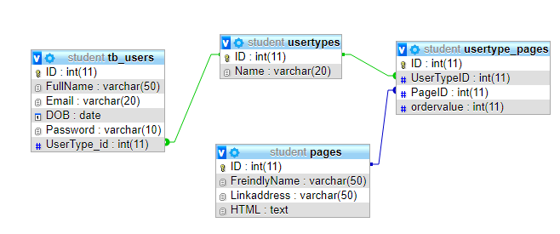

* Implement the following classes in php + login.

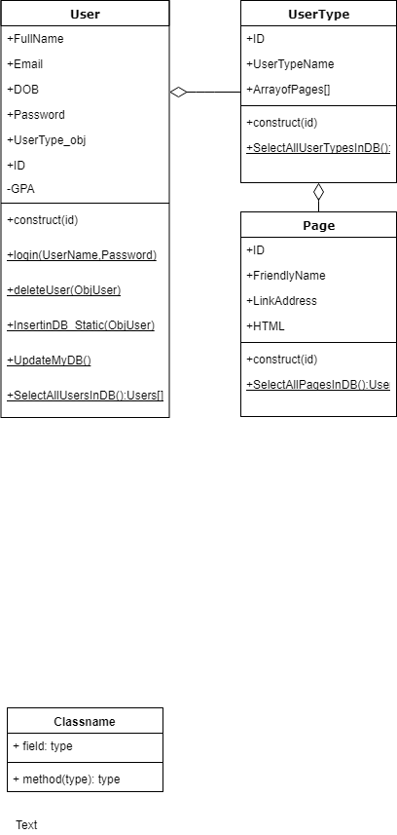

* Create AssignPage.php page that contains the following form

